ГКОУ МО ВСОШ № 20

Ежегодный областной творческий конкурс «Кроссмейстер»

Тема: «English speaking countries»

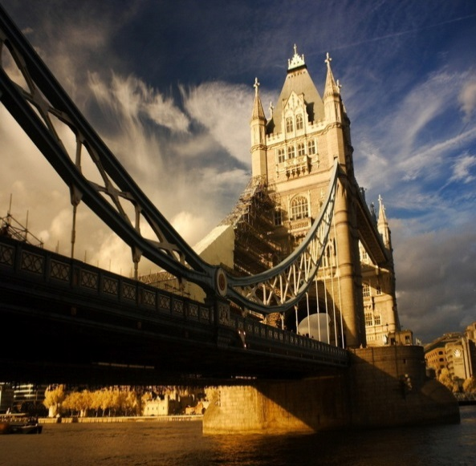

Автор: Ефимов Евгений Александрович
Кураторы: учитель английского языка Рябков В. А.

пгт Зеленоборский
2014
 |  |  | 1 G | E | O | R | G | E |  |  | W |  | A |  | S |  | H |  | I |  | N |  | G |  | T |  | 2  O | N
 |  |  |  |  |  |  |  |  |  |  |  |  |  |  |  |  |  |  |  |  |  |  |  |  |  |  | P
3  M |  |  | 4  B | R | U | C | E |  |  | W | I |  | l |  | L |  | I |  | S |  |  |  |  |  |  |  | R
U |  |  | A |  |  |  |  |  |  |  |  |  |  |  |  |  |  |  |  |  |  |  |  |  |  |  | A
H |  |  | R |  |  |  |  |  |  |  |  | 4F |  |  |  |  |  |  |  |  |  |  |  |  |  |  | H
A |  |  | A |  | 6  L |  | G | E | N |  |  | R |  | Y |  |  |  | F |  | O |  | R |  | D
M |  |  | C |  | A |  |  |  |  |  |  | A |  |  |  |  |  |  |  |  |  |  |  |  |  |  | W
M |  |  | K |  | D |  |  | E | R |  |  | N |  | E |  | S |  | T |  |  |  | H |  | E |  | M | I | N |  | G |  | W |  | A |  | Y
A |  |  |  |  | Y |  |  |  |  |  |  | K |  |  |  |  |  |  |  |  |  |  |  |  |  |  | N
D |  |  | O |  |  |  |  |  |  |  |  | L |  |  |  |  |  |  |  | 9B |  |  |  |  |  |  | F |  |  |  |  | L
 |  |  | B |  | G |  |  |  |  |  |  | I |  |  |  |  |  |  |  | E |  |  |  |  |  |  | R |  |  |  |  | O
11 A | B | R | A | H | A | M |  | L | I |  |  | N |  | k |  | O |  | l |  | N |  |  |  | 12T |  |  | E |  |  |  |  | U
L |  |  | M |  | G |  |  |  |  |  |  |  |  |  |  |  |  |  |  | J |  |  |  | O |  |  | Y |  |  |  |  | I
I |  |  | A |  | A |  |  |  |  |  |  | 18R |  |  |  |  |  |  |  | A |  |  |  | M |  |  |  |  |  |  |  | S
 |  |  |  |  |  |  |  |  |  |  |  | O |  |  |  |  |  |  |  | M |  |  |  |  |  |  |  |  |  |  |  |  |  |  |  | 14M
 |  |  |  |  |  |  |  |  |  |  |  | O |  |  |  | 16 W |  | R |  | I |  | G |  | H |  | T |  |  |  |  |  | A |  |  |  | A
 |  |  |  |  |  |  |  | 16E |  |  |  | S |  |  |  |  |  |  |  | N |  |  |  | A |  |  |  |  |  |  |  | R |  |  |  | R
 |  |  |  |  |  |  |  | L |  |  |  | E |  |  |  | R |  |  |  |  |  |  |  | N |  |  |  | 19E |  |  |  | M |  |  |  | T
 |  |  | 17S |  | 20M |  |  | V |  |  |  | V |  |  |  | U |  |  |  | F |  |  |  | K |  |  |  | M |  |  |  | S |  |  |  | I |  |  |  |  |  |  |  | 21  C
 |  |  | A |  | I |  |  | I |  |  |  | E |  |  |  | 22P |  | A |  | R |  | I |  | S |  |  | H | I |  | L |  | T |  | O |  | N |  |  |  |  |  |  |  | H
 |  |  | M |  | C |  |  | S |  |  |  | L |  |  |  | E |  |  |  | A |  |  |  |  |  |  |  | N |  |  |  | R |  |  |  |  |  |  |  |  |  |  |  | U
 |  |  | U |  | H |  |  |  |  |  |  | T |  |  |  | R |  |  |  | N |  |  |  |  |  |  |  | E |  |  |  | O |  |  |  | L |  |  |  |  |  |  |  | C
 |  |  | E |  | E |  |  | P |  |  |  |  |  |  |  | T |  |  |  | K |  |  |  |  |  |  |  | M |  |  |  | N |  |  |  | U |  |  |  |  |  |  |  | K
 |  |  | L |  | A |  |  | R |  |  |  |  |  |  |  |  |  |  |  | L |  |  |  |  |  |  |  |  |  |  |  | G |  |  |  | S
 |  |  |  |  | L |  |  | E |  |  |  |  |  |  |  | M |  |  |  | I |  |  |  |  |  |  |  |  |  |  |  |  |  |  |  | H |  |  |  |  |  |  |  | N
 |  |  | C |  |  |  |  | S |  |  |  |  |  |  |  | U |  |  |  | N |  |  |  |  |  | 23T | O | M |  | A |  | S |  |  |  | E |  | D |  | I |  | S |  | O |  | n
 |  |  | L |  | J |  |  | L |  |  |  |  |  |  |  | R |  |  |  |  |  |  |  |  |  |  |  |  |  |  |  |  |  |  |  | R |  |  |  |  |  |  |  | R
 |  |  | E |  | O |  |  | E |  |  |  |  |  |  |  | D |  |  |  |  |  |  |  |  |  |  |  |  |  |  |  |  |  |  |  |  |  |  |  |  |  |  |  | R
 |  |  | 24M | A | R | I | l | Y | N |  |  |  |  | M |  | O |  | N |  | R |  | O |  | E |  |  |  |  |  |  |  |  |  |  |  | K |  |  |  |  |  |  |  | I
 |  |  | E |  | D |  |  |  |  |  |  |  |  |  |  | C |  |  |  |  |  |  |  |  |  |  |  |  |  |  |  |  |  |  |  | I |  |  |  |  |  |  |  | S
 |  |  | N |  | A |  |  |  |  |  |  |  |  |  |  | H |  |  |  |  |  |  |  | 28A |  | L |  | C |  | A |  | P |  | O |  | N |  | E
 |  |  | S |  | N |  |  |  |  |  |  |  |  |  |  |  |  |  |  |  |  |  |  |  |  |  |  |  |  |  |  |  |  |  |  | G

 |  |  | 1 |  |  |  |  |  |  |  |  |  |  |  |  |  |  | 2
3 |  |  | 4
 |  |  |  |  |  |  |  |  |  | 4
 |  |  |  |  | 6
 |  |  |  |  |  |  |  |  |  |  |  |  |  | 9
11 |  |  |  |  |  |  |  |  |  |  |  |  |  |  |  | 12
 |  |  |  |  |  |  |  |  |  | 18
 |  |  |  |  |  |  |  |  |  |  |  |  |  |  |  |  |  |  |  |  |  |  | 14
 |  |  |  |  |  |  |  |  |  |  |  | 16
 |  |  |  |  |  |  |  | 16
 |  |  |  |  |  |  |  |  |  |  |  |  |  |  |  |  |  |  | 19
 |  |  | 17 |  | 20 |  |  |  |  |  |  |  |  |  |  |  |  |  |  |  |  |  |  |  |  |  |  |  |  | 21
 |  |  |  |  |  |  |  |  |  |  |  | 22
 |  |  |  |  |  |  |  |  |  |  |  |  |  |  |  |  | 23
 |  |  | 24
 |  |  |  |  |  |  |  |  |  |  |  |  |  |  |  | 28

Across
1. Who is the first President of the United States of America, commander-in-chief of the Continental Army
4. The famous american actor, producer, and musician. He starred in such films as like Pulp Fiction, The Fifth Element,
7.The great american industrialist, whose slogan was "a car for everyone"
8.Who won Nobel Prize in Literature in 1954
11. 16th President of the United States, which ending slavery, and promoting economic and financial modernization
15. The brothers, who invented the first successful airplane construction
22. American businesswoman, potential future heiress, producer, singer and socialite,
23. One of the most famous American inventor who received more than 1,000 patents
24. The major sex symbol during the 1950s. She is an american actress, singer, model and showgirl,
25. One of the most famous Italian-American gangster who led a Prohibition-era crime syndicate
Down
2. Who is an american media proprietor, talk show host, actress, producer and philanthropist. First and only female black billionaire
3.,Whose had a real name is Cassius Clay.
4. Current president of the United States
5. President of the United States who elected to more than two terms
6. American singer and songwriter. She is famous for the "poker face"
9. One of the Founding Fathers of the United States.
10. Famous American jazz trumpeter and singer
12. American actor, producer, writer, and director. He is known for his role as the title character in Forrest Gump
13. English comic actor, film director and composer best known for his work during the silent film era
14. American clergyman, activist, and prominent leader in the African-American Civil Rights Movement.
16. One of the most popular American singers of the 20th century. King of Rock and Roll
17. American author and humorist, better known by his pen name Mark Twain
18. American media mogul. He is the founder and Chairman and CEO of News Corporation, he is a majority owner of American newspaper publishers and TV
19. Most famous blonde American rapper, record producer, songwriter and actor
20. A famous former American professional basketball player
21. American martial artist and actor. He knows what is "mavashi geri"

